
计算机与信息学院
数据结构实验报告

专 业 班 级 | 计算机科学与技术22-2班
学生姓名及学号 | 陈祥烨 2022212153
课程教学班号 | 0529822B-001
任 课 教 师 | 胡学钢
实验指导教师 | 李培培
实验地点 | C402
2022 ~2023 学年第 二 学期

实验序号及名称：实验 四 扩展线性结构的应用实验
实验时间∶ 2023年 5 月 5 日
预习内容
一、实验目的和要求∶
（1）理解数组与广义表两种扩展线性结构的特点；
（2）根据实际问题，熟练掌握基于多维数组与广义表的
存储结构及有关算法的设计。
二、实验任务∶
<1> 设计算法实现稀疏矩阵的运算应用。
要求：1）设计稀疏矩阵类；2）给出测试用例，实现n组稀疏矩阵的相加与相乘。
<2>问题描述：本科生导师制：每个老师指导n个学生，老师带的研究生也可直接负责本科生。数据元素具有如下形式：
- (老师, ((研究生1,(本科生1, …, 本科生m)), … ))
- (老师, (本科生1, …, 本科生m))
设计算法，实现上述任务的插入、删除、查询、输出。
要求：
1）老师、研究生与本科生个数、相关信息自定义；
2）设计广义表类；
3）给出测试用例。
三、实验准备方案，包括以下内容：
<1>
散列表类定义：
const int MAX = 5;

struct Tuple
{
int ti; //行
int tj; //列
int data; //值
Tuple* next;
Tuple() {}
Tuple(int i, int j, int data) {
ti = i;
tj = j;
this->data = data;
next = NULL;
}
Tuple(Tuple* tuple) {
ti = tuple->ti;
tj = tuple->tj;
this->data = tuple->data;
next = NULL;
}
};

class TripleList
{
public:
TripleList(); //默认构造函数
TripleList(int A[][MAX]); //三元表构造函数
TripleList(TripleList& tl); //三元表拷贝构造
TripleList(const TripleList& tl); //三元表拷贝构造
~TripleList(); //析构函数

int get_length() const; //获取长度
Tuple* get_front() const; //获得头结点
Tuple* get_rear() const; //获得尾结点
int getValue(int i,int j) const; //获得矩阵对应元素的值

void append(Tuple* t); //尾增
void insert(Tuple* t); //插入 按照序号先i后j 确定Key不同
void print() const; //打印三元表
TripleList& operator= (const TripleList& tl); //等号运算符重载
TripleList& operator+ (const TripleList& tl); //加号运算符重载
TripleList& operator* (const TripleList& tl); //乘号运算符重载

private:
int count;
Tuple *front,*rear; //头结点未实例化，尾结点的下一个元素为NULL
};
相加：
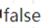
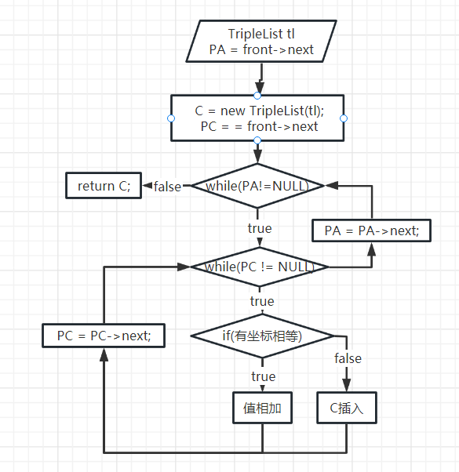
相乘：
双层循环比遍历新矩阵，每一个左行右列相乘相加，在散列表寻找值时，散列表中关键字不存在返回0；存在则返回其value
<2>
广义表数据结构的定义展示：
enum StaffType { TUTOR/*导师*/ = 0, GRADUATESTUDENT/*研究生*/ = 1, UNDERGRADUATE/*本科生*/ = 2, FRONT/*头结点*/ = 3 };

struct Staff {
StaffType type;
string name;
Staff* next;
Staff* student;
Staff();
Staff(StaffType type, string name);
};

class TutorialSystem{
private:
Staff* m_front; //头结点为空
public:
TutorialSystem();
~TutorialSystem();
bool insert(string name,int option); //录入成功为false;录入失败为true
bool deleteStaff(string name); //删除对外接口，找到并删除为true
bool find(string name); //查找找到为true
void show(); //显示对外接口

bool isEmpty(); //判断为空，空位true
private:
void _show(Staff* staff); //显示功能实现
bool _deleteStaff(string name, Staff* staff); //删除功能实现
void _destroy(Staff* staff); //删除该结点以及其所有的next 和 student

int getTCount(Staff* staff); //获得导师数量
int getGCount(Staff* staff); //获得研究生数量
int getUCount(Staff* staff); //获得本科生数量
};
数据结构图展示：
单链表1
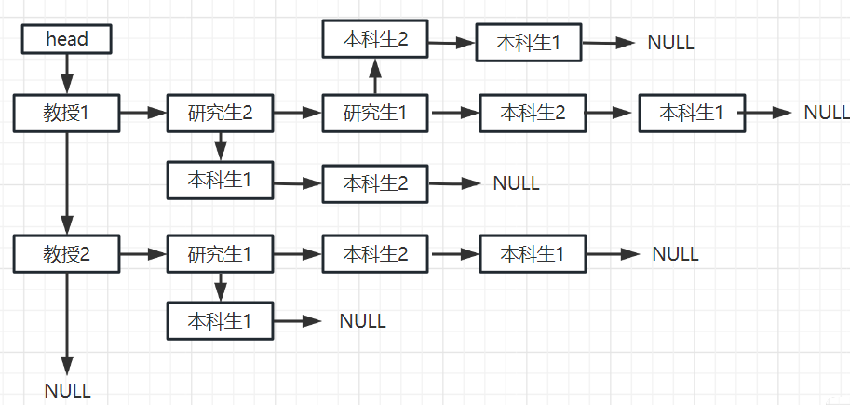
单链表2
单链表3
广义表有三部分组成：教授组，教授所带的学生组（包括研究生和本科生），研究生所带的学生组，由外到内三层构成，由student 和 next 控制分支，type 做为分支的控制条件
方法原理描述：
插入：
输入姓名，选择职业。
- 如果为教授，当做单链表直接尾插
- 如果为研究生，选择导师并找到，接到Tutor的指针student，保证研究生在本科生前面，方便管理；
- 如果为本科生，选择有GraduateStudent带还是Tutor带，找到导师。如果导师为Tutor，接到最后一个研究生的next；如果为GraduateStudent，接到该研究生的student
删除
While循环遍历三个链表部分，姓名为判断依据（暂未考虑重名）
查询
名字为判断依据，利用三层循环遍历查查找；
显示
显示教授，研究生，本科生的数量，显示导师制成员表构成
数量显示：教授，研究生用while直接累加while结束条件分别为staff->next != NULL和curStudent != NULL && curStudent->type == GRADUATESTUDENT；本科生利用递归完成，是本科生则return getUCount(staff->next)+getUCount(staff->student) + 1;不是就不 + 1；
结构显示：
三层循环遍历依次输出；是否进入更深层的链表由类型判断

实验内容
一、实验用仪器、设备：
笔记本电脑：VS2022
二、实验内容与步骤（过程及数据记录）：
<1> 设计算法实现稀疏矩阵的运算应用。
要求：1）设计稀疏矩阵类；2）给出测试用例，实现n组稀疏矩阵的相加与相乘。
代码：
Test.cpp
#include"triple list.h"

int main()
{
//初始化
int a[MAX][MAX] = { 0 };
for (int i = 0; i < MAX; i++)
for (int j = 0; j < MAX; j++)
if (i == j)a[i][j] = 1;

int b[MAX][MAX] = { 0 };
for (int i = 0; i < MAX; i++)
for (int j = 0; j < MAX; j++)
if (i + j == 4)b[i][j] = 1;

TripleList triplelist1(a);
TripleList triplelist2(b);
TripleList triplelist3 = triplelist1 + triplelist2 + triplelist1 + triplelist2;
TripleList triplelist4 = (triplelist1 + triplelist2) * (triplelist1 + triplelist2);
cout << "list1:" << endl;
triplelist1.print();
cout << "list2:" << endl;
triplelist2.print();
cout << "list3 = list1 + list2 + list1 + list2:" << endl;
triplelist3.print();
cout << "list4 = (list1 + list2) * (list1 + list2):" << endl;
triplelist4.print();

return 0;
}
Triple list.h
#pragma once
#include<iostream>
using namespace std;
const int MAX = 5;

struct Tuple
{
int ti; //行
int tj; //列
int data; //值
Tuple* next;
Tuple() {}
Tuple(int i, int j, int data) {
ti = i;
tj = j;
this->data = data;
next = NULL;
}
Tuple(Tuple* tuple) {
ti = tuple->ti;
tj = tuple->tj;
this->data = tuple->data;
next = NULL;
}
};

class TripleList
{
public:
TripleList(); //默认构造函数
TripleList(int A[][MAX]); //三元表构造函数
TripleList(TripleList& tl); //三元表拷贝构造
TripleList(const TripleList& tl); //三元表拷贝构造
~TripleList(); //析构函数

int get_length() const; //获取长度
Tuple* get_front() const; //获得头结点
Tuple* get_rear() const; //获得尾结点
int getValue(int i,int j) const; //获得矩阵对应元素的值

void append(Tuple* t); //尾增
void insert(Tuple* t); //插入 按照序号先i后j 确定Key不同
void print() const; //打印三元表
TripleList& operator= (const TripleList& tl); //等号运算符重载
TripleList& operator+ (const TripleList& tl); //加号运算符重载
TripleList& operator* (const TripleList& tl); //乘号运算符重载

private:
int count;
Tuple *front,*rear; //头结点未实例化，尾结点的下一个元素为NULL
};
Triple list.cpp
#include"triple list.h"
//--------------------------------TripleList构造与析构-------------------------

TripleList::TripleList()
{
Tuple* tuple = new Tuple;
tuple->next = NULL;
front = tuple;
rear = tuple;
count = 0;
}

TripleList::TripleList(int A[][MAX]) //三元表构造函数
{
Tuple* tuple = new Tuple;
tuple->next = NULL;
front = tuple;
rear = tuple;
count = 0;

Tuple* PA = front;
for (int i = 0; i < MAX; i++)
for (int j = 0; j < MAX; j++)
if (A[i][j] != 0)
{
Tuple* tuple = new Tuple(i,j,A[i][j]);

PA->next = tuple;
PA = tuple;
rear = PA;
count++;
}
}

TripleList::TripleList(TripleList& tl) //三元表拷贝构造
{
Tuple* tuple = new Tuple;
tuple->next = NULL;
front = tuple;
rear = tuple;
count = 0;

Tuple* PA = front;
Tuple* PB = tl.get_front()->next;
while (PB != NULL)
{
Tuple* tuple = new Tuple(PB);

PA->next = tuple;
PA = tuple;
rear = PA;
count++;

PB = PB->next;
}
}

TripleList::TripleList(const TripleList& tl) //三元表拷贝构造
{
Tuple* tuple = new Tuple;
tuple->next = NULL;
front = tuple;
rear = tuple;
count = 0;

Tuple* PA = front;
Tuple* PB = tl.get_front()->next;
while (PB != NULL)
{
Tuple* tuple = new Tuple(PB);

PA->next = tuple;
PA = tuple;
rear = PA;
count++;

PB = PB->next;
}
}

TripleList::~TripleList() //析构函数
{
Tuple* temp, * PA = front;
while (PA != NULL)
{
temp = PA;
PA = PA->next;
delete temp;
}
count = 0;
front = NULL;
rear = NULL;
}

//--------------------------------TripleList工具包-------------------------

void TripleList::append(Tuple* t) //尾增
{
Tuple* tuple = new Tuple(t);

rear->next = tuple;
rear = tuple;
count++;
}

void TripleList::insert(Tuple* t)
{
Tuple* tuple = new Tuple(t);
Tuple* ptr = front;
if (count == 0) { //表为空
ptr->next = tuple;
rear = tuple;
count++;
return;
}
if (t->ti < ptr->next->ti || (t->ti == ptr->next->ti && t->tj < ptr->next->tj)) { //表不为空，除去第一个就可以插入的特例
tuple->next = ptr->next;
ptr->next = tuple;
count++;
return;
}
ptr = ptr->next;
while (ptr->next != NULL) {
if (ptr->next != NULL && ptr->ti == t->ti) {
while (ptr->next != NULL && t->ti == ptr->next->ti && t->tj < ptr->next->tj) {
ptr = ptr->next;
}
if (ptr->next == NULL) {
ptr->next = tuple;
rear = tuple;
count++;
return;
}
else if (t->ti > ptr->ti && t->ti == ptr->next->ti && t->tj > ptr->next->tj) {
ptr = ptr->next;
}
else {
tuple->next = ptr->next;
ptr->next = tuple;
count++;
return;
}
}
else {
if (ptr->next != NULL && t->ti == ptr->next->ti && t->tj < ptr->next->tj) {
tuple->next = ptr->next;
ptr->next = tuple;
count++;
return;
}
ptr = ptr->next;
}
}
if (ptr->next == NULL) {
ptr->next = tuple;
rear = tuple;
count++;
return;
}
}

void TripleList::print() const //打印三元表
{
if (count == 0)
cout << "list is empty!" << endl;
else
{
Tuple* PA = front->next;
cout << "i\tj\tdata" << endl;
while (PA != NULL)
{
cout << PA->ti + 1 << "\t" << PA->tj + 1 << "\t" << PA->data << endl;
PA = PA->next;
}
}
}
int TripleList::get_length() const //获取长度
{
return count;
}

Tuple* TripleList::get_front() const //获得头结点
{
return front;
}

Tuple* TripleList::get_rear() const //获得尾结点
{
return rear;
}
int TripleList::getValue(int i, int j) const
{
int value = 0;
Tuple* ptr = front->next;
for (; ptr != NULL; ptr = ptr->next) {
if (i == ptr->ti && j == ptr->tj) {
return ptr->data;
}
}
return 0;
}
//--------------------------------TripleList算法-------------------------
TripleList& TripleList::operator= (const TripleList& tl) //加号运算符重载
{
//删除原有数据
Tuple* temp, * PA = front;
while (PA != NULL)
{
temp = PA;
PA = PA->next;
delete temp;
}
count = 0;
front = NULL;
rear = NULL;

//深拷贝新数据
Tuple* tuple = new Tuple;
tuple->next = NULL;
front = tuple;
rear = tuple;
count = 0;

Tuple* NPA = front;
Tuple* PB = tl.get_front()->next;
while (PB != NULL)
{
Tuple* tuple = new Tuple(PB);

NPA->next = tuple;
NPA = tuple;
rear = NPA;
count++;

PB = PB->next;
}

return *this;
}

TripleList& TripleList::operator+ (const TripleList& tl)//加号运算符重载
{
TripleList* C = new TripleList(tl);
Tuple* PA;
Tuple* PC;
bool isappend = 1;

for (PA = front->next; PA != NULL; PA = PA->next, isappend = 1)
{
for (PC = C->get_front()->next; PC != NULL; PC = PC->next)
{
//坐标相等，则值相加；遍历完没有相等，则 C 尾增
if (PC->ti == PA->ti && PC->tj == PA->tj)
{
PC->data += PA->data;
isappend = 0; //为1 表示矩阵中该位置是0，三元组表需要尾增
break;
}
}
if (isappend == 1)
C->insert(PA);
}
return *C;
}

TripleList& TripleList::operator* (const TripleList& tl) //乘号运算符重载
{
TripleList* tlist = new TripleList();
for (int i = 0; i < MAX; i++) {
for (int j = 0; j < MAX; j++) {
int value = 0;
for (int a = 0; a < MAX; a++) {
value += getValue(i, a) * tl.getValue(a, j);
}
if (value != 0) {
Tuple* tuple = new Tuple(i, j, value);
tlist->append(tuple);
}
}
}
return *tlist;
}
<2>问题描述：本科生导师制：每个老师指导n个学生，老师带的研究生，也可直接负责本科生。数据元素具有如下形式：
- (老师, ((研究生1,(本科生1, …, 本科生m)), … ))
- (老师, (本科生1, …, 本科生m))
设计算法，实现上述任务的插入、删除、查询、输出。
要求：
1）老师、研究生与本科生个数、相关信息自定义；
2）设计广义表类；
3）给出测试用例。
代码
Test.cpp
#include"TutorialSystem.h"

void showContents(){
cout << "-----------------------\n"
<< "欢迎使用导师制管理系统!\n"
<< "目录：\n"
<< "1.录入\n"
<< "2.删除\n"
<< "3.查询\n"
<< "4.显示\n"
<< "5.退出\n"
<< "-----------------------\n"
<< "请选择您所需要的功能：";
}

int main() {
TutorialSystem turtorialsystem;
while (1)
{
showContents();
int option;
cin >> option;
switch(option){
case 1: {
string name;
while (1) {
int option;
cout << "PS：输入 over 结束录入功能\n"
<< "请输入姓名：";
cin >> name;
if (name == "over") {break;}
cout << "1.导师\n"
<< "2.研究生\n"
<< "3.本科生\n";
recinoption:
cout << "请选择职业：";
cin >> option;
if (option > 3 || option < 1) {
cout << "输入有误，请重新输入！" << endl;
goto recinoption;
}
if (turtorialsystem.insert(name, option)) {
cout << "录入成功！" << endl;
}
else {
cout << "系统尚未收录导师信息，请先录入导师！" << endl;
}
}
break;
}
case 2: {
if (!turtorialsystem.isEmpty()) {
string name;
cout << "请输入所要删除的姓名：";
cin >> name;
if (turtorialsystem.deleteStaff(name)) {
cout << "删除成功！" << endl;
}
else {
cout << "输入姓名有误或未录入该职员信息!";
}
}
else {cout << "数据为空！请先录入数据！";}
}
break;
case 3: {
if (turtorialsystem.isEmpty()) {
cout << "数据为空！请先录入数据！";
}
else {
string name;
cout << "请输入所要查找的姓名：";
cin >> name;
if (!turtorialsystem.find(name)) {
cout << "输入姓名有误或未录入该职员信息!" << endl;
}
break;
}
}
case 4:
turtorialsystem.show();
break;
case 5:
cout << "欢迎下次使用！" << endl;
system("pause");
return 0;
default:
cout << "选项不合法，请重新操作！" << endl;
}
system("pause");
system("cls");
}
return 0;
}
TutorialSystem.h
#pragma once
#include<iostream>
#include<string>
using namespace std;
enum StaffType { TUTOR/*导师*/ = 0, GRADUATESTUDENT/*研究生*/ = 1, UNDERGRADUATE/*本科生*/ = 2, FRONT/*头结点*/ = 3 };

struct Staff {
StaffType type;
string name;
Staff* next;
Staff* student;
Staff();
Staff(StaffType type, string name);
};

class TutorialSystem{
private:
Staff* m_front; //头结点为空
public:
TutorialSystem();
~TutorialSystem();
bool insert(string name,int option); //0 录入成功; 1 录入失败
bool deleteStaff(string name); //删除对外接口
bool find(string name); //查找
void show(); //显示对外接口

bool isEmpty(); //判断为空
private:
void _show(Staff* staff); //显示功能实现
bool _deleteStaff(string name, Staff* staff); //删除功能实现
void _destroy(Staff* staff); //删除该结点以及其所有的next 和 student

int getTCount(Staff* staff); //获得导师数量
int getGCount(Staff* staff); //获得研究生数量
int getUCount(Staff* staff); //获得本科生数量
};
TutorialSystem.cpp
#include"TutorialSystem.h"

//-------------------------Staff构造-----------------------
Staff::Staff() {
next = NULL;
student = NULL;
}
Staff::Staff(StaffType type, string name = "head") {
this->type = type;
this->name = name;
this->next = NULL;
this->student = NULL;
}
//-------------------------TutorialSystem构造与方法-----------------------
TutorialSystem::TutorialSystem() {
m_front = new Staff(FRONT);
}

TutorialSystem::~TutorialSystem(){
_destroy(m_front);
}

bool TutorialSystem::insert(string name, int option) {
switch (option){
case 1: {//导师
Staff* staff = new Staff(TUTOR, name);
Staff* temp = m_front;
while (temp->next != NULL) {
temp = temp->next;
}
temp->next = staff;
return true;
}

case 2: {//研究生
Staff* staff = new Staff(GRADUATESTUDENT, name);
Staff* temp = m_front->next;
if (temp == NULL) { return false; }
//展示导师信息
int teacherCount = 1;
for (; temp != NULL; temp = temp->next, teacherCount++) {
cout << teacherCount << "." << temp->name << endl;
}
teacherCount--;
//选择导师
int option;
recinoption1:
cout << "请选择导师：";
cin >> option;
if (option > teacherCount || option < 1) {
cout << "输入有误，请重新输入！" << endl;
goto recinoption1;
}
//录入研究生信息
temp = m_front->next;
for (int i = 1; i < option; i++) {
temp = temp->next;
}
if (temp->student == NULL) { //导师暂未带学生
temp->student = staff;
}
else {
staff->next = temp->student;
temp->student = staff;
}
return true;
}

case 3: {//本科生
Staff* staff = new Staff(UNDERGRADUATE, name);
//展示导师信息
Staff* tempT = m_front->next;
if (tempT == NULL) { return false; }
int teacherCount = 1;
for (; tempT != NULL; tempT = tempT->next, teacherCount++) {
cout << teacherCount << "." << tempT->name << endl;
}
//选择导师
int option;
recinoption2:
cout << "请选择导师：";
cin >> option;
if (option > teacherCount || option < 1) {
cout << "输入有误，请重新输入！" << endl;
goto recinoption2;
}
//找到导师
tempT = m_front->next;
for (int i = 1; i < option; i++) {
tempT = tempT->next;
}
Staff* tempG = tempT->student;
if (tempG == NULL ) { //导师暂未带学生
tempT->student = staff;
}
else if (tempG->type == UNDERGRADUATE) {//导师暂未带研究生
staff->next = tempT->student;
tempT->student = staff;
}
else {
//展示导师所带研究生
int graduateCount = 0;
for (; tempG != NULL && tempG->type == GRADUATESTUDENT; tempG = tempG->next) {
cout << ++graduateCount << "." << tempG->name << endl;
}
cout << graduateCount + 1 << ".直接选择导师" << endl;
//选择研究生
recinoption3:
cout << "请选择研究生：";
cin >> option;
if (option > graduateCount + 1 || option < 1) {
cout << "输入有误，请重新输入！" << endl;
goto recinoption3;
}
//录入学生信息
tempG = tempT->student;
if (option == graduateCount + 1) { //直接选择导师
for (int i = 1; i < graduateCount; i++) {
tempG = tempG->next;
}
staff->next = tempG->next;
tempG->next = staff;
}
else { //选择研究生
for (int i = 1; i < option; i++) {
tempG = tempG->next;
}
if (tempG->student == NULL) { //研究生未带本科生
tempG->student = staff;
}
else {
staff->next = tempG->student;
tempG->student = staff;
}
}
}
return true;
}
}
}

bool TutorialSystem::deleteStaff(string name){
Staff* temp1 = m_front;
Staff* cur1 = m_front->next;
while (cur1 != NULL) { //找导师
if (cur1->name == name) {
temp1->next = cur1->next;
_destroy(cur1->student);
delete cur1;
return true;
}
else {
Staff* temp2 = cur1;
Staff* cur2 = cur1->student;
while (cur2 != NULL) {
if (cur2->type == GRADUATESTUDENT) {
if (cur2->name == name) {
if (temp2 == cur1) { //没找到
temp2->student = cur2->next;
}
else {
temp2->next = cur2->next;
}
_destroy(cur2->student);
delete cur2;
return true;
}
Staff* temp3 = cur2;
Staff* cur3 = cur2->student;
while (cur3 != NULL) { //如果是研究生
if (cur3->name == name) { //由研究生直到的本科生中找到要删除的人
if (temp3 == cur2) { //没找到
temp3->student = cur3->next;
}
else {
temp3->next = cur3->next;
}
delete cur3;
return true;
}
if (temp3 == cur2) { //没找到
temp3 = temp3->student;
}
else {
temp3 = temp3->next;
}
cur3 = cur3->next;
}
}
else { //如果是本科生
if (cur2->name == name) {
if (temp2 == cur1) { //没找到
temp2->student = cur2->next;
}
else {
temp2->next = cur2->next;
}
delete cur2;
return true;
}
}
if (temp2 == cur1) {
temp2 = temp2->student;
}
else {
temp2 = temp2->next;
}
cur2 = cur2->next;
}
}
temp1 = temp1->next;
cur1 = cur1->next;
}
return false;
}

bool TutorialSystem::find(string name) {
Staff* cur1 = m_front->next;
while (cur1 != NULL) {
if (cur1->name == name) {
cout << name << " 为导师" << endl;
return true;
}
Staff* cur2 = cur1->student;
while (cur2 != NULL) {
if (cur2->name == name) {
if (cur2->type == GRADUATESTUDENT) {
cout << name << " 为研究生，导师为教授 " << cur1->name << endl;
}
else {
cout << name << " 为本科生，导师为教授 " << cur1->name << endl;
}
return true;
}
Staff* cur3 = cur2->student;
while (cur3 != NULL) {
if (cur3->name == name) {
cout << name << " 为本科生，导师为研究生 " << cur2->name << endl;
return true;
}
cur3 = cur3->next;
}
cur2 = cur2->next;
}
cur1 = cur1->next;
}
return false;
}

void TutorialSystem::show() {
cout << "导师数量：" << getTCount(m_front) << endl;
cout << "研究生数量：" << getGCount(m_front) << endl;
cout << "本科生数量:" << getUCount(m_front) << endl;
cout << "导师\t研究生/本科生" << endl;
_show(m_front->next);
}
bool TutorialSystem::isEmpty()
{
if (m_front->next == NULL) {
return true;
}
return false;
}

void TutorialSystem::_destroy(Staff* staff){
if (staff == NULL) {
return;
}
_destroy(staff->student);
_destroy(staff->next);
delete staff;
}
void TutorialSystem::_show(Staff* staff) {
if (staff == NULL) {
cout << "暂未收录人员信息" << endl;
}
else {
while (staff != NULL) {
cout << staff->name << ":";
Staff* cur1 = staff->student;
if (cur1 == NULL) {
cout << "\tNULL" << endl;
}
else {
while (cur1 != NULL) {
if (cur1->type == GRADUATESTUDENT) {
cout << "\t" << cur1->name << ":";
Staff* cur2 = cur1->student;
if (cur2 == NULL) {
cout << "\tNULL";
}
else {
while (cur2 != NULL) {
cout << "\t" << cur2->name;
cur2 = cur2->next;
}
}
cout << endl;
}
else {
cout << "\t" << cur1->name << endl;
}
cur1 = cur1->next;
}
}
staff = staff->next;
}
}
}

bool TutorialSystem::_deleteStaff(string name, Staff* staff)
{
if (staff == NULL) {
return false;
}
else {
if (staff->name == name) {
return true;
}
else {
return _deleteStaff(name, staff->next) || _deleteStaff(name, staff->student);
}
}

}

int TutorialSystem::getTCount(Staff* staff) {
int count = 0;
while (staff->next != NULL) {
count++;
staff = staff->next;
}
return count;
}
int TutorialSystem::getGCount(Staff* staff) {
int count = 0;
Staff* curStudent;
while (staff->next != NULL) {
staff = staff->next;
if (staff->student != NULL) {
curStudent = staff->student;
while (curStudent != NULL && curStudent->type == GRADUATESTUDENT) {
count++;
curStudent = curStudent->next;
}
}
}
return count;
}
int TutorialSystem::getUCount(Staff* staff) {
if (staff == NULL) {
return 0;
}
else {
if (staff->type == UNDERGRADUATE) {
return getUCount(staff->next)+getUCount(staff->student) + 1;
}
else {
return getUCount(staff->next) + getUCount(staff->student);
}
}
}

三、实验结果分析、思考题解答∶
<1>测试：
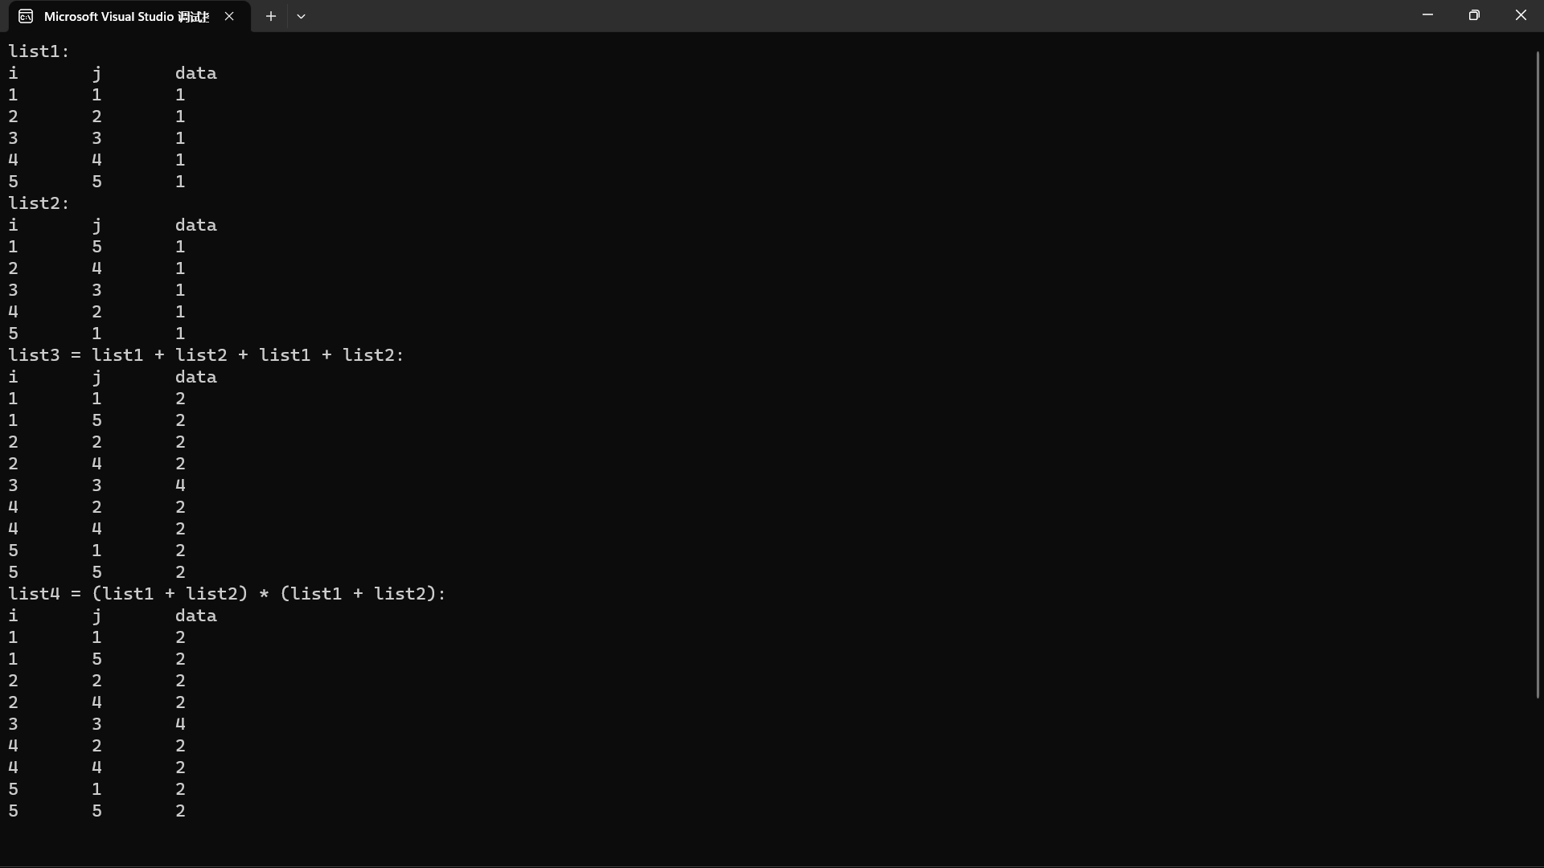
<2>测试：
1.录入
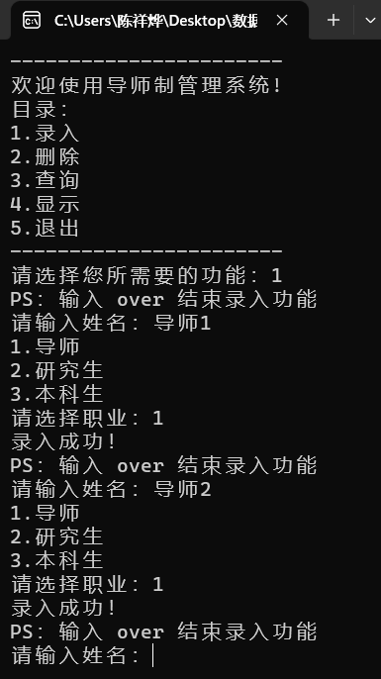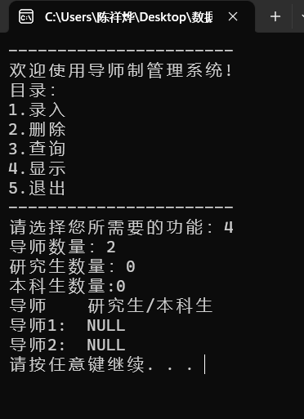
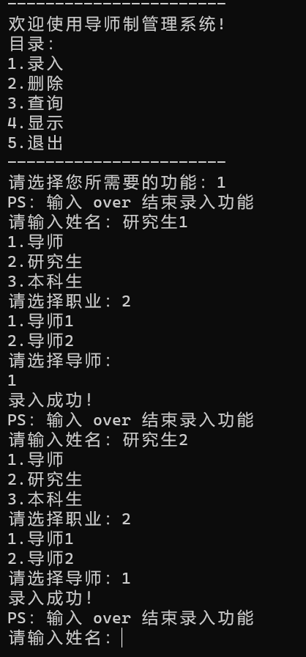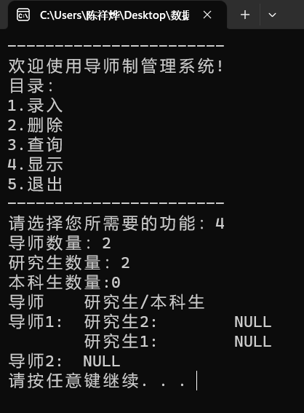
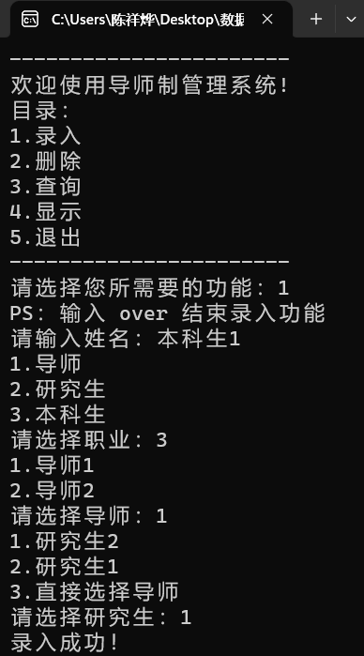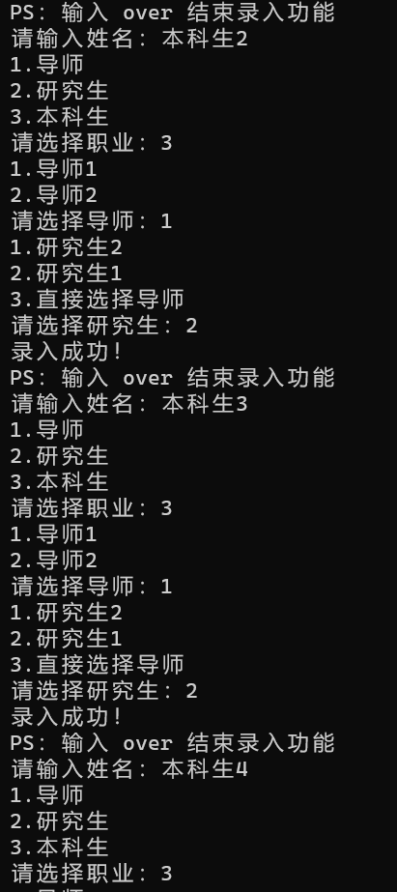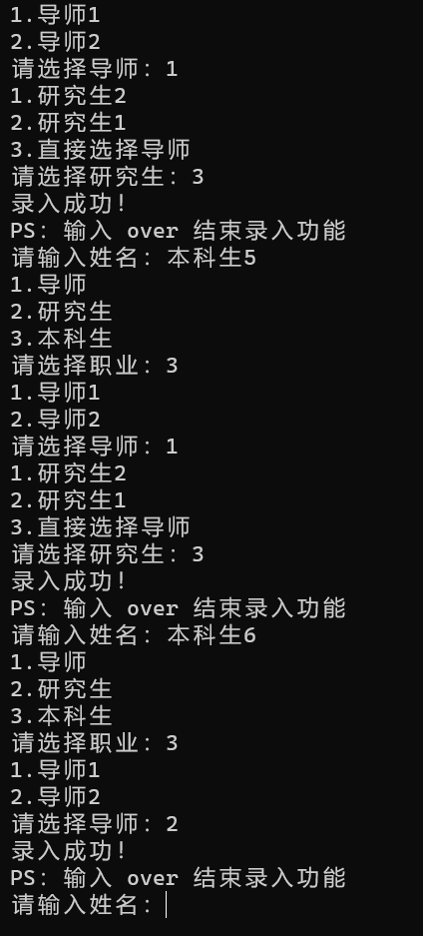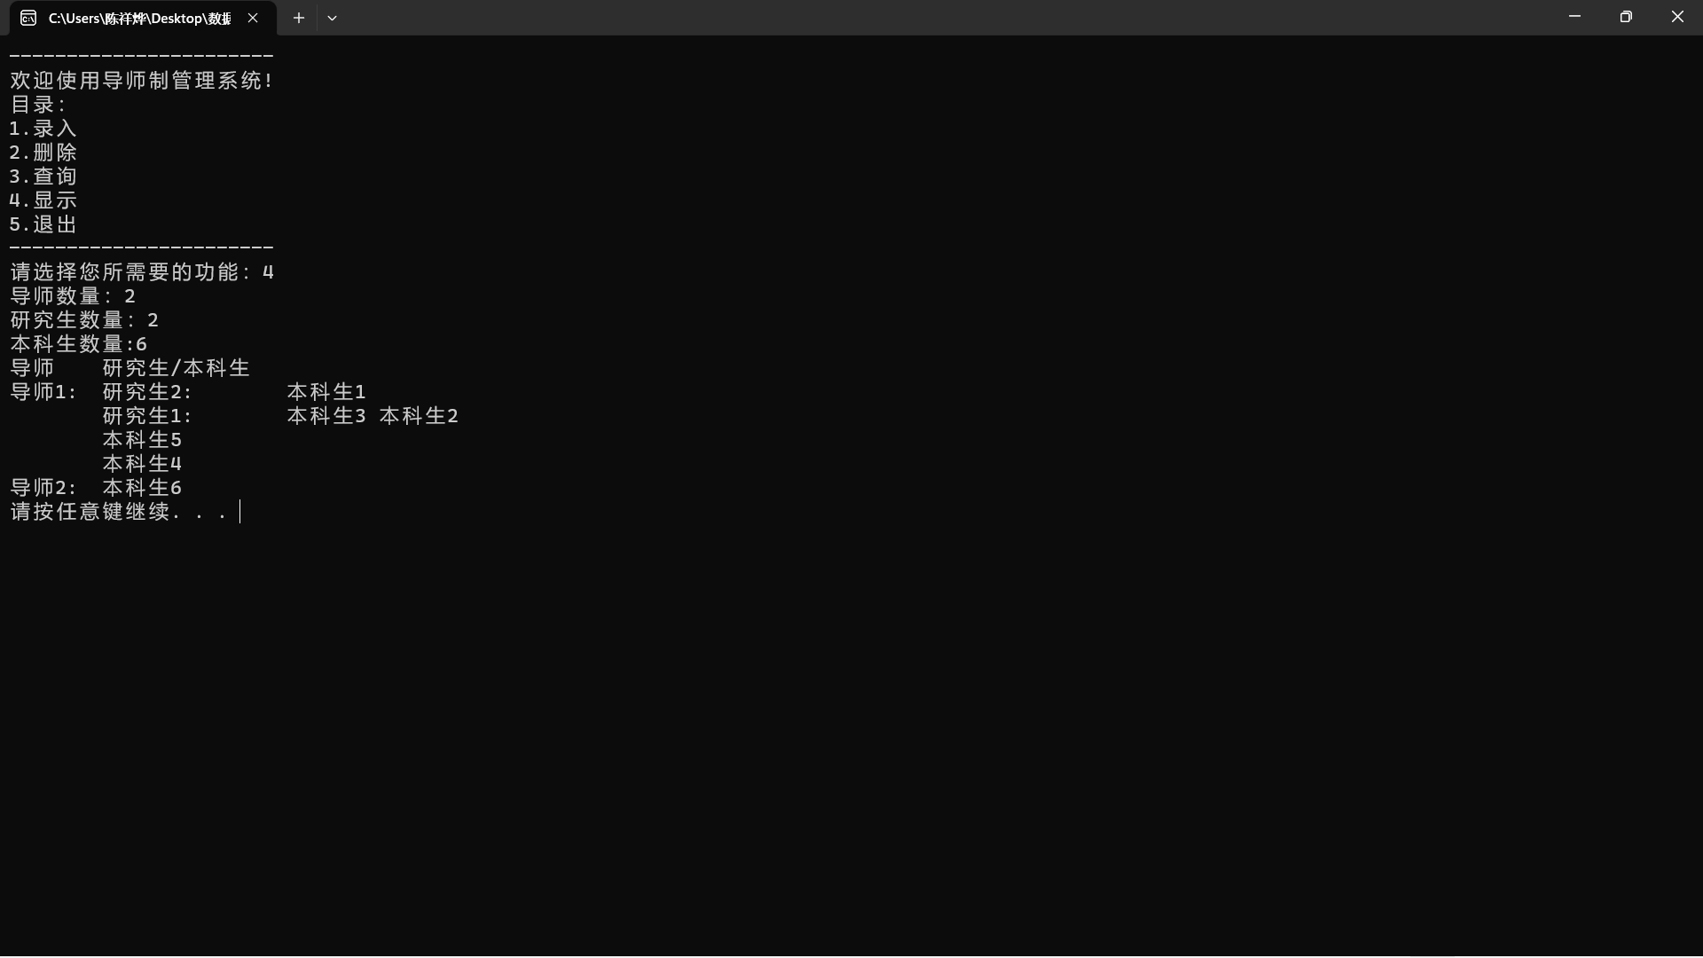
2.查询
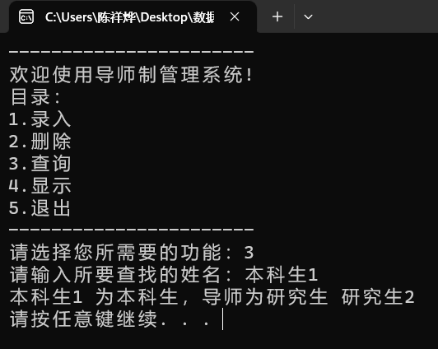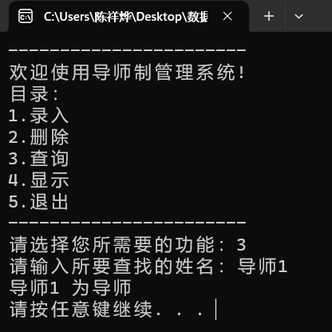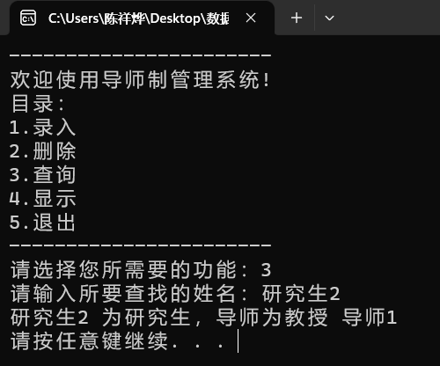
3.显示
4.删除
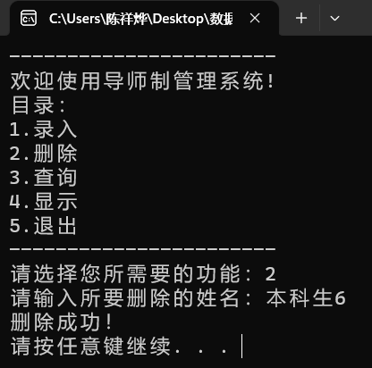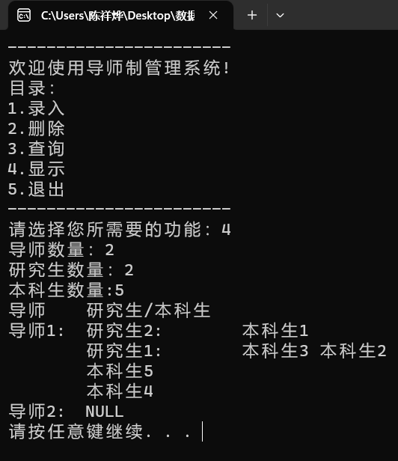
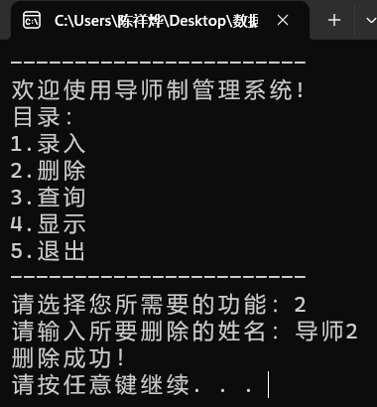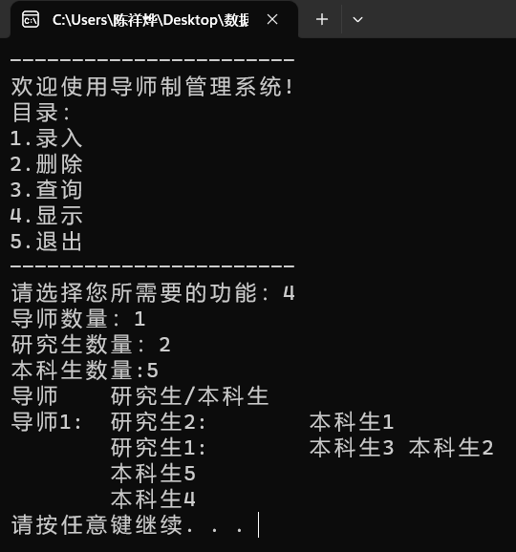
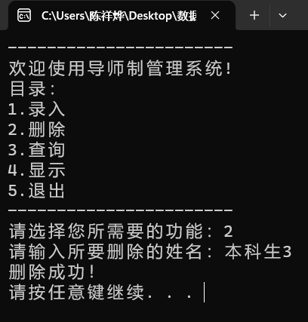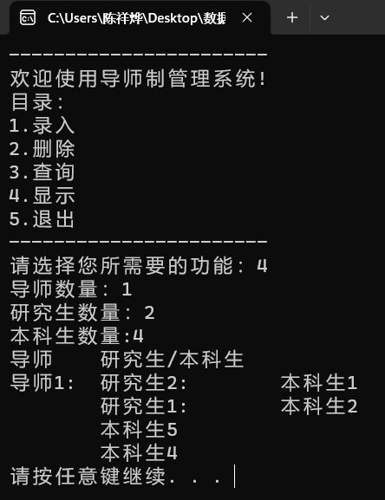
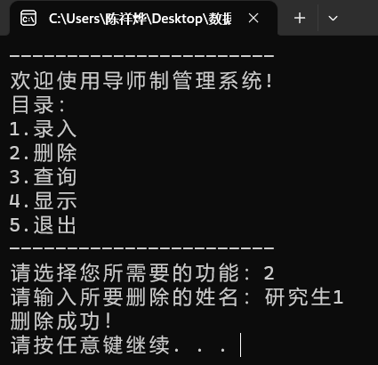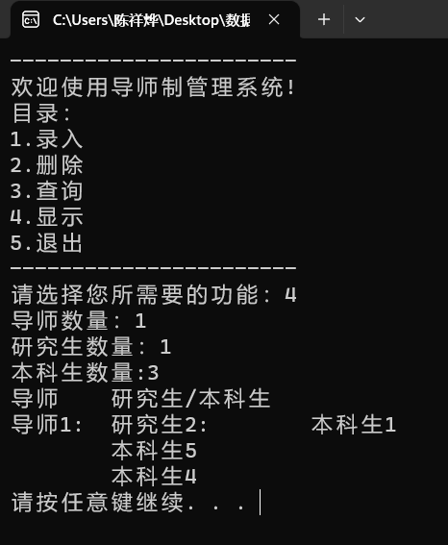
四、感想、体会、建议∶
<2>
////总结一：
////为什么构造子节点要传进去二级指针？
////刚开始我传进一级指针的时候，我发现创建完成后，gl = NULL，为什么？
////因为没有一个变量记录gl第一个节点的地址啊，所以最后找不到它了。
////这时候就需要一个二级指针，指向该头节点的地址。
//
// //总结二：
////外部操作自定义数据类型，设置独立对外接口，加强数结构安全性，减少无操作
//
////思考一：
////为什么不把深度，值结点长度设为参数？
////广义表相比单链表，链队列等深度为1的数据结构而言，插入，删除等操作更为复杂，
////对于总数的变化不好统计，并且在复杂程序中插入删除操作次数会远多于求深度的操作
////总体而言，求深度单另设一函数，减少运算时间
实验成绩∶

指导教师签名：
年 月 日

